Courier Management System

**GROUP MEMBERS**

|  |  |
| --- | --- |
| Student1432047 | HAREEM REHAN AFZAL |
| Student1432461 | ABDUL BASIT |
| Student1432059 | IBRAHIM KHATUDA |
| Student1432035 | WAJIHA NADEEM |
| Student1432254 | MUHAMMAD HASSAN |

**FACULTY :Miss Bakhtawar Siraj**

**BATCH CODE :2211B2**

**CURRICULUM :7062**

**Back End (Admin Site)**

We created two sites as required in our project Front End (user)

And Back End ( Admin ) as we were told. Now we are Showing

you how our Back End Site looks after completing all of our work.

Here How It Looks :

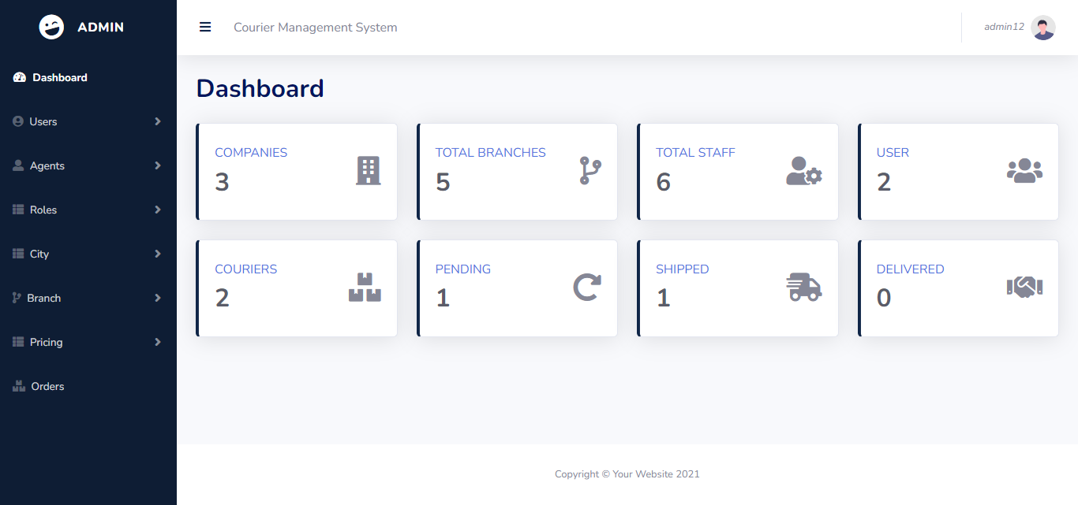

**CODE:**

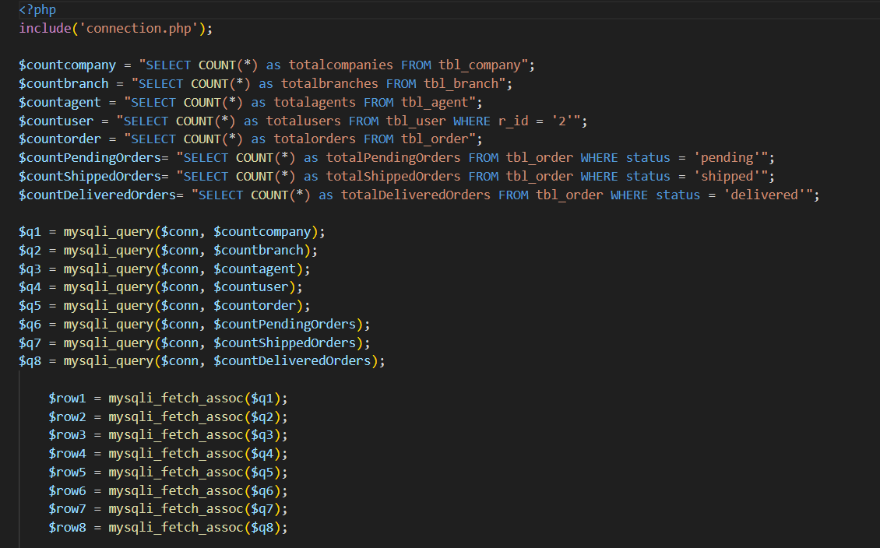

ASSIGN ORDER:

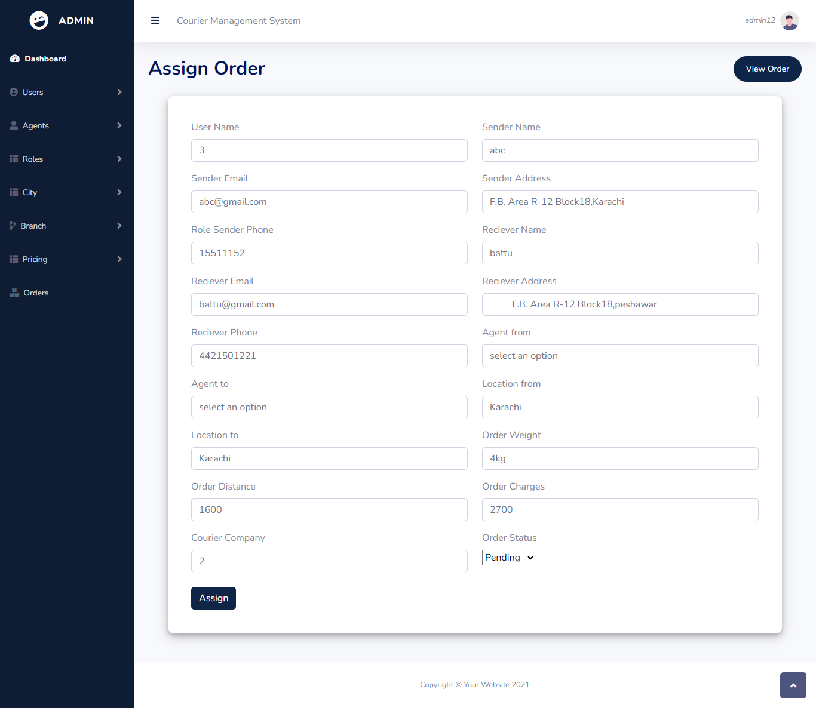

CODE:

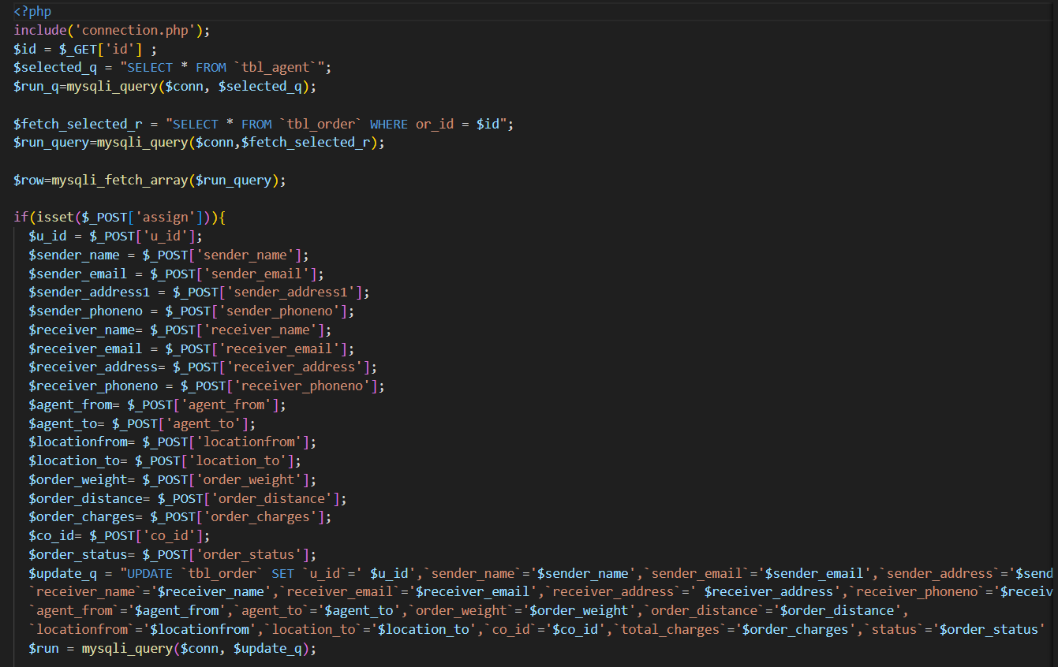

ADD USER:

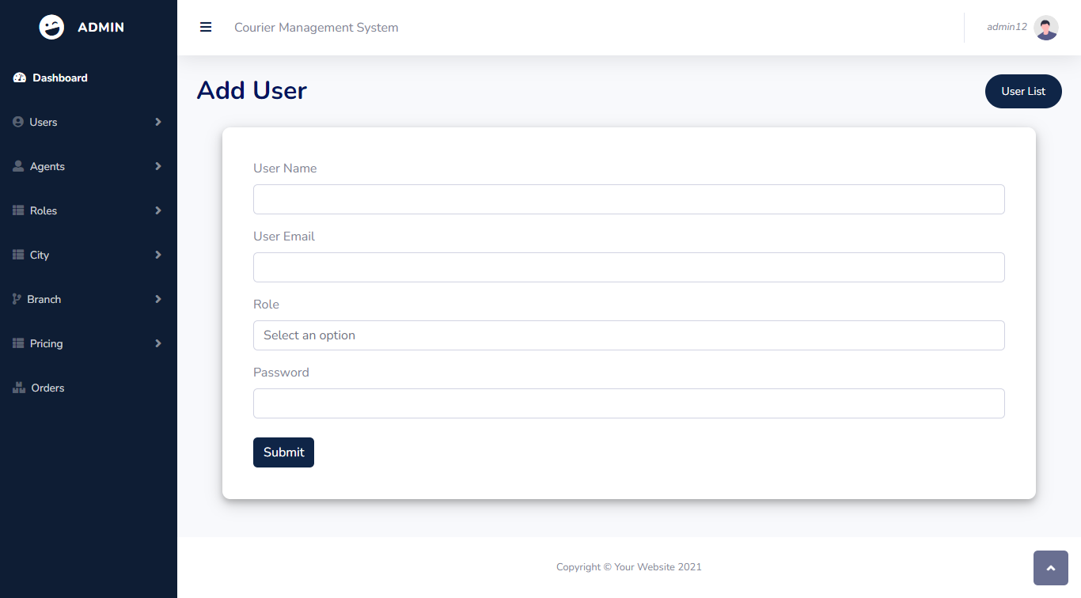

CODE:

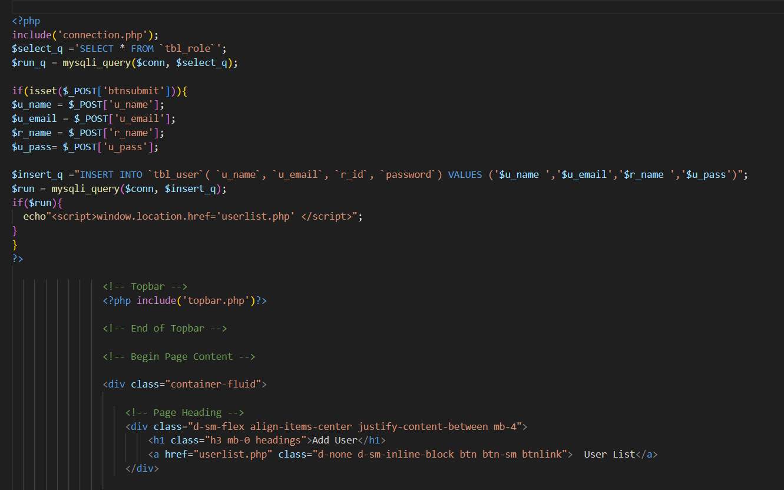

VIEW ORDERS:

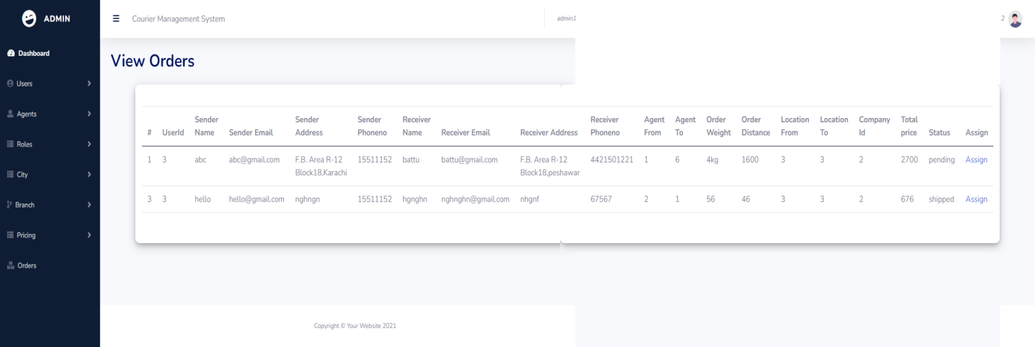

CODE:

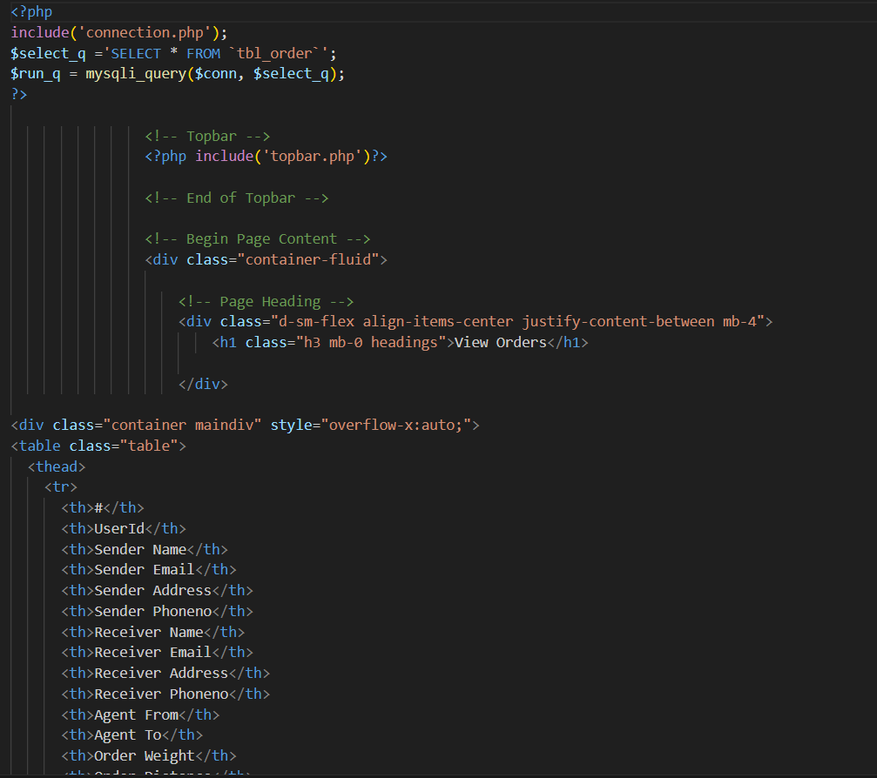

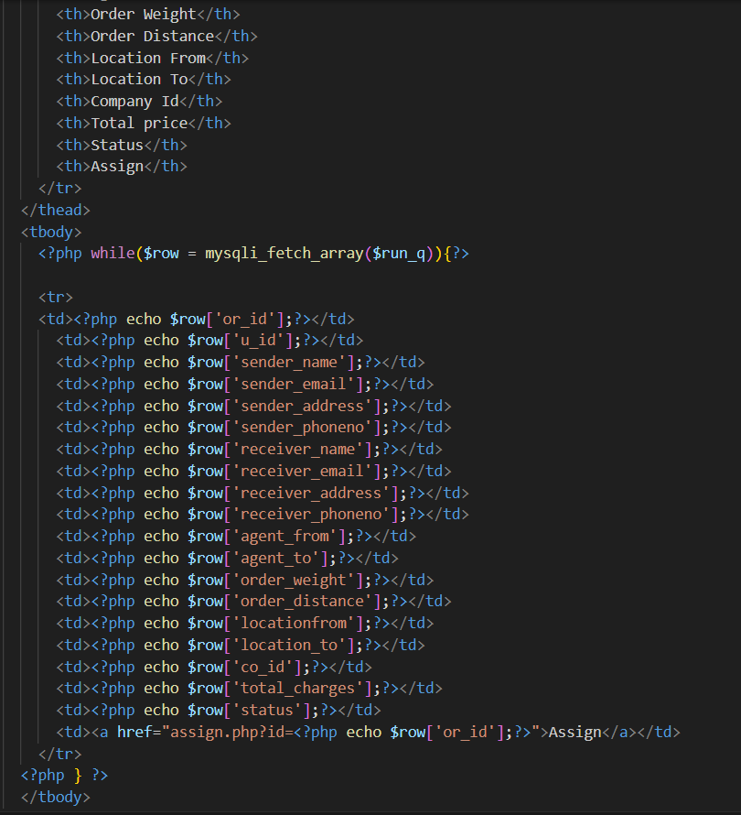

VIEW USERS:

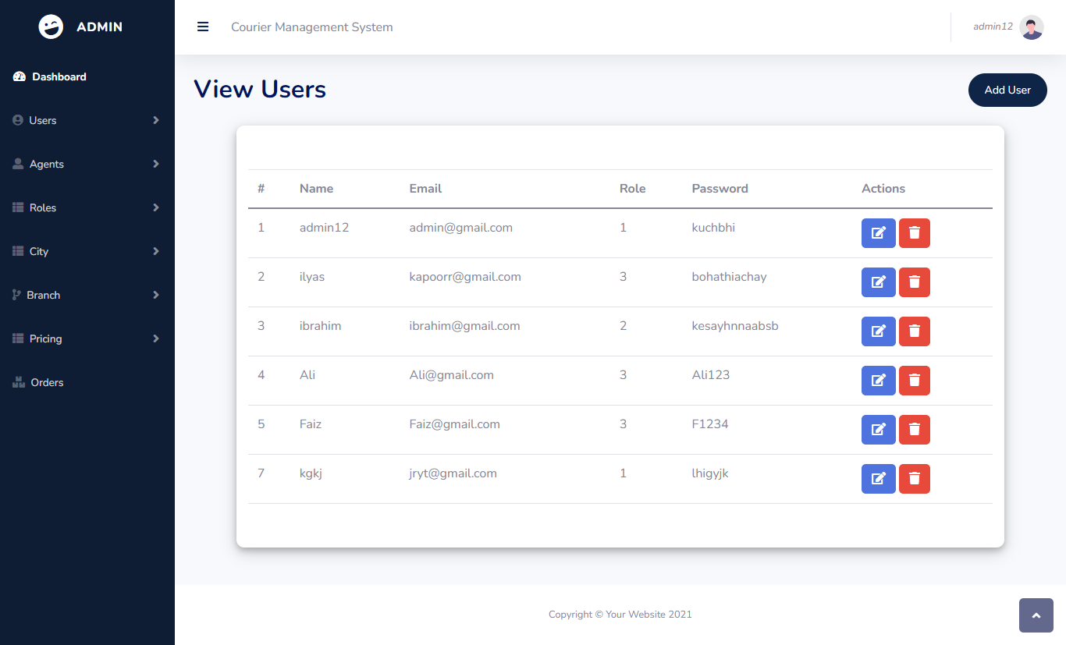

CODE:

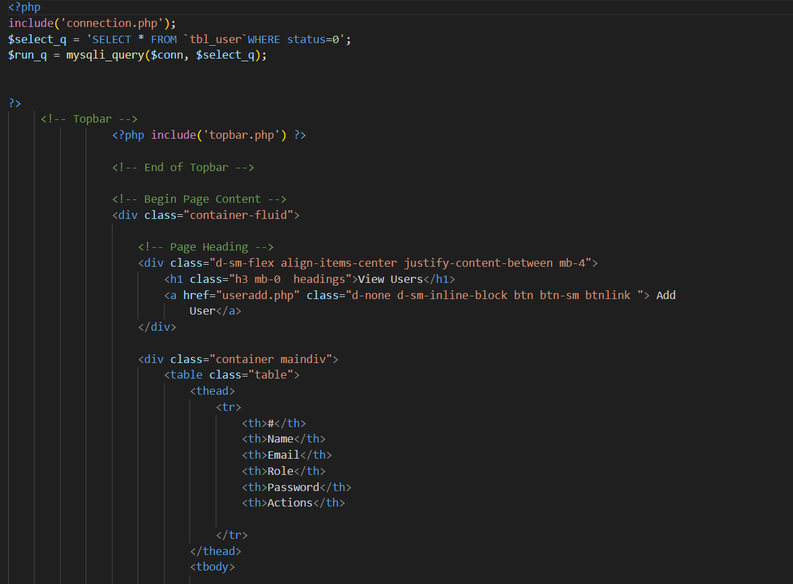

UPDATE USER:

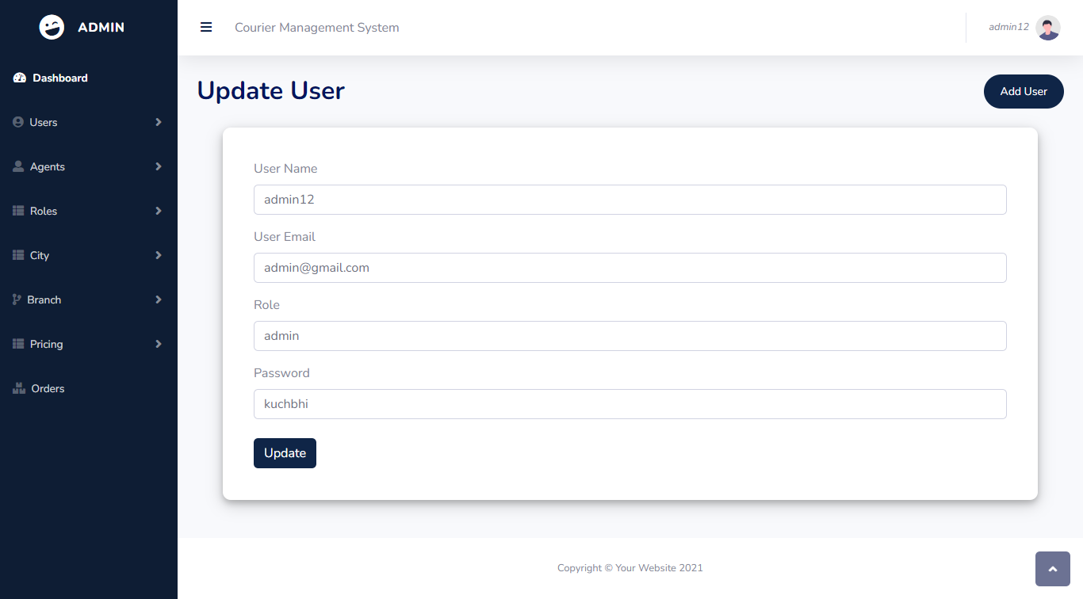

CODE:

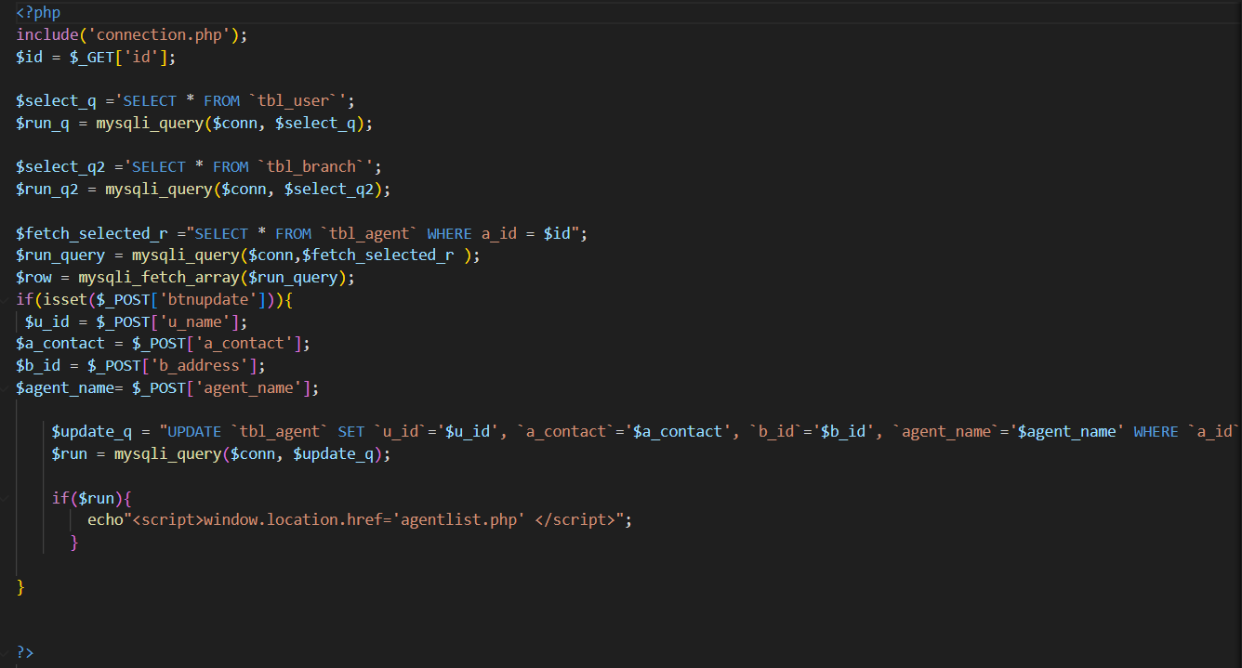

**START OF USER SITE (Front End)**

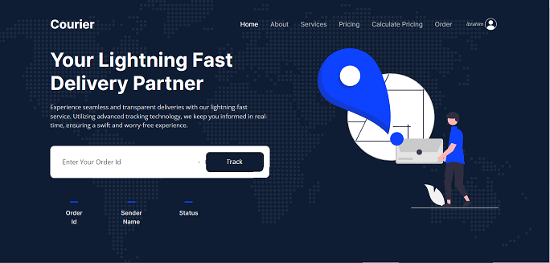

CODE:

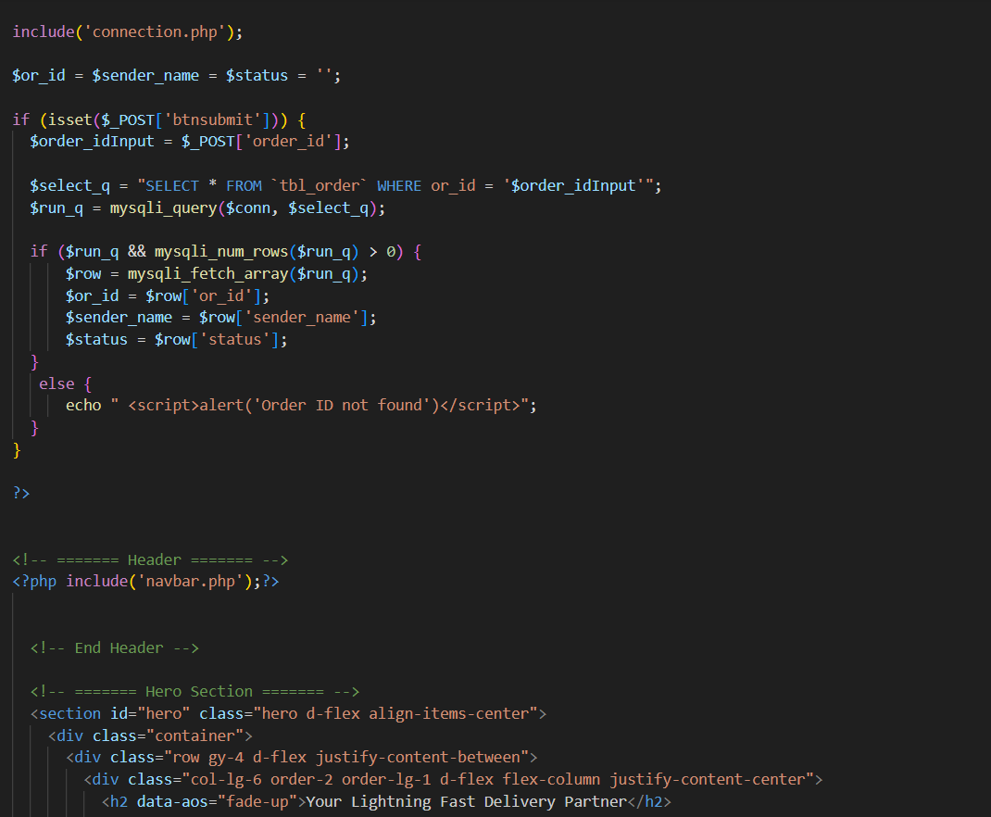

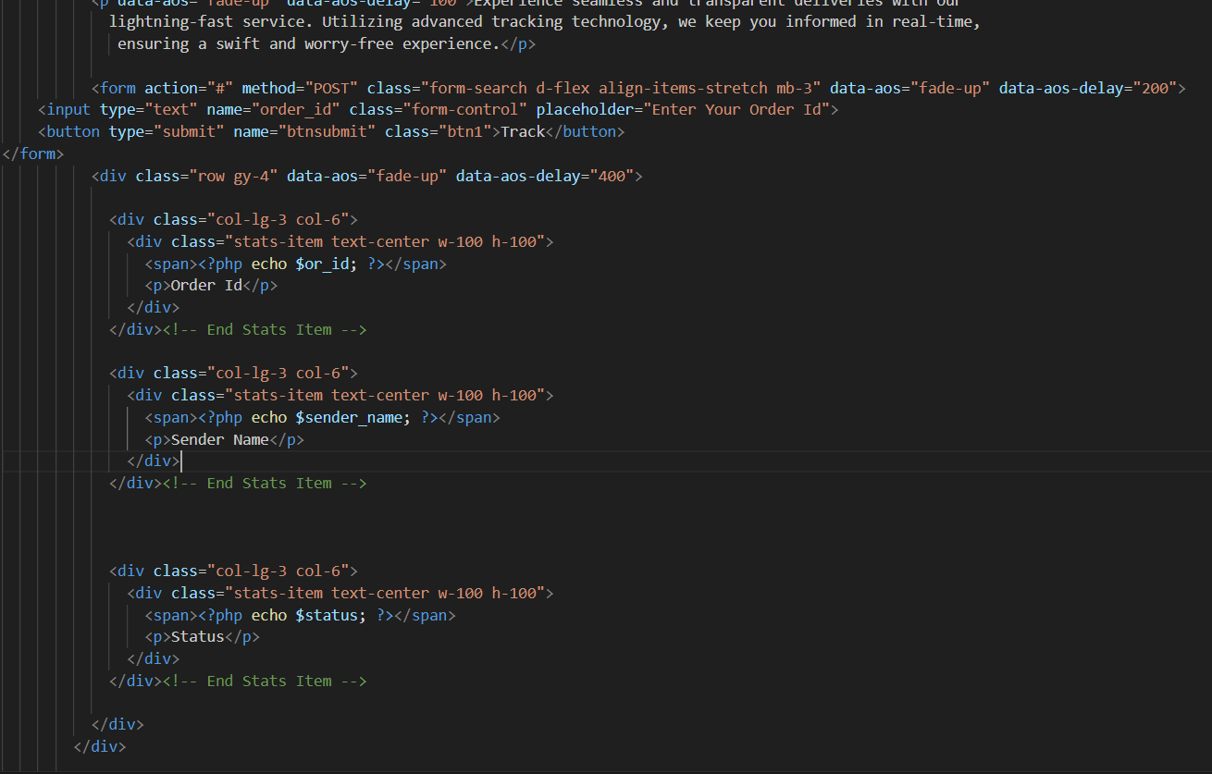

OUR CPMPANIES:

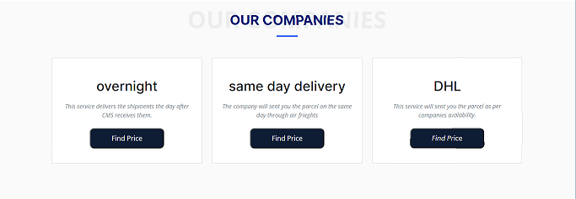

CODE:  
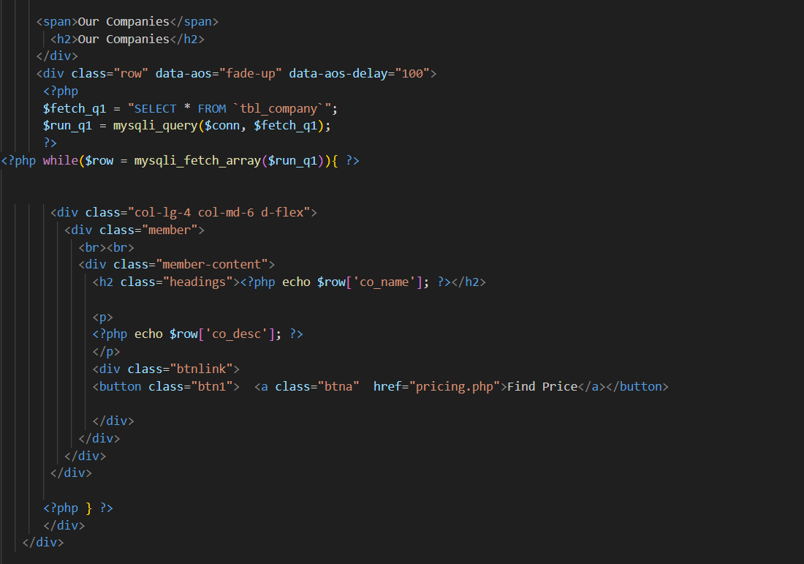

OUR SERVICES:



CODE:

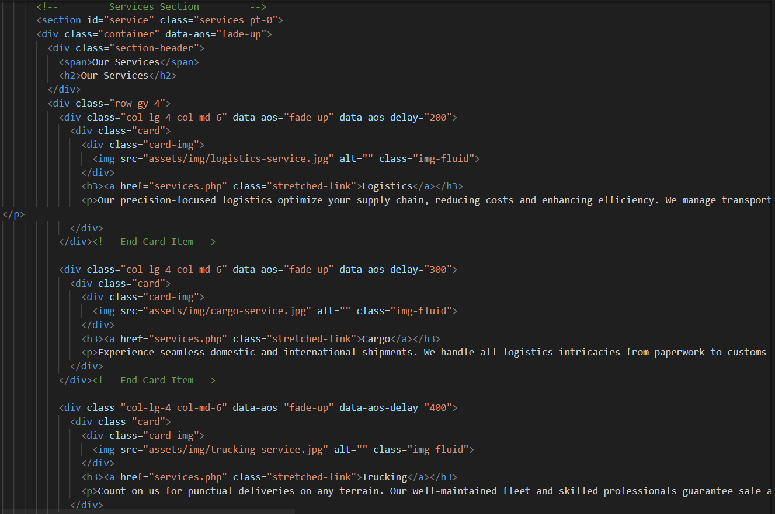

ABOUT US:

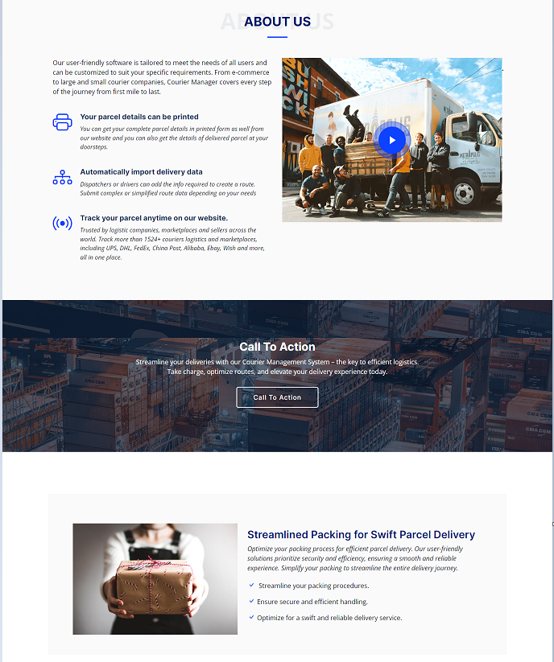

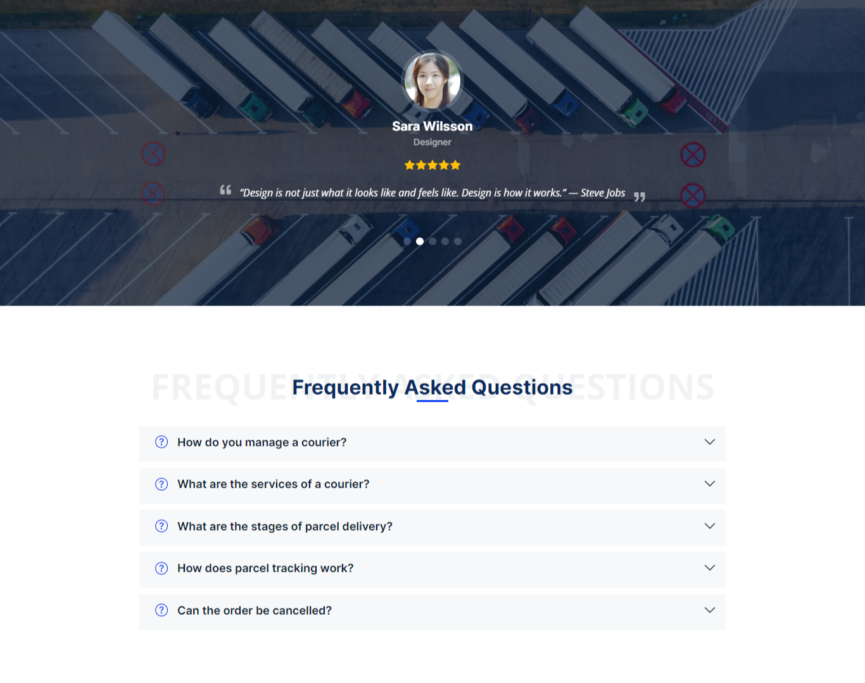

CODE:

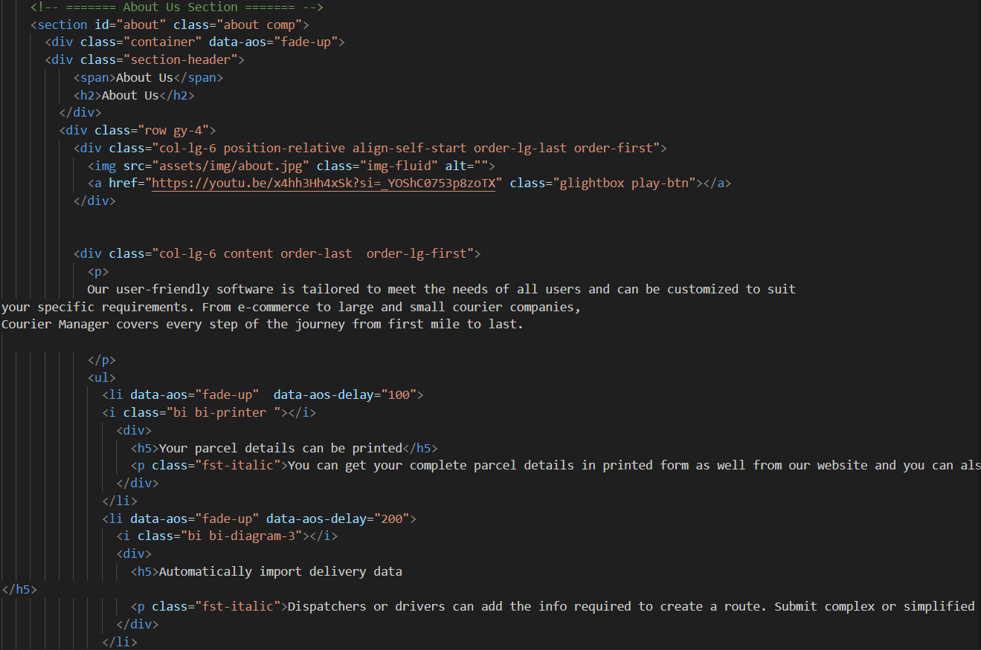

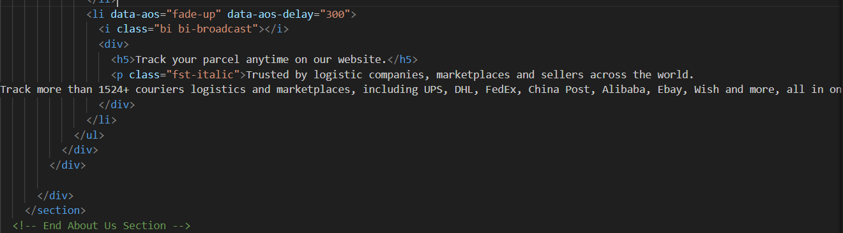

USER PRICING PLAN:

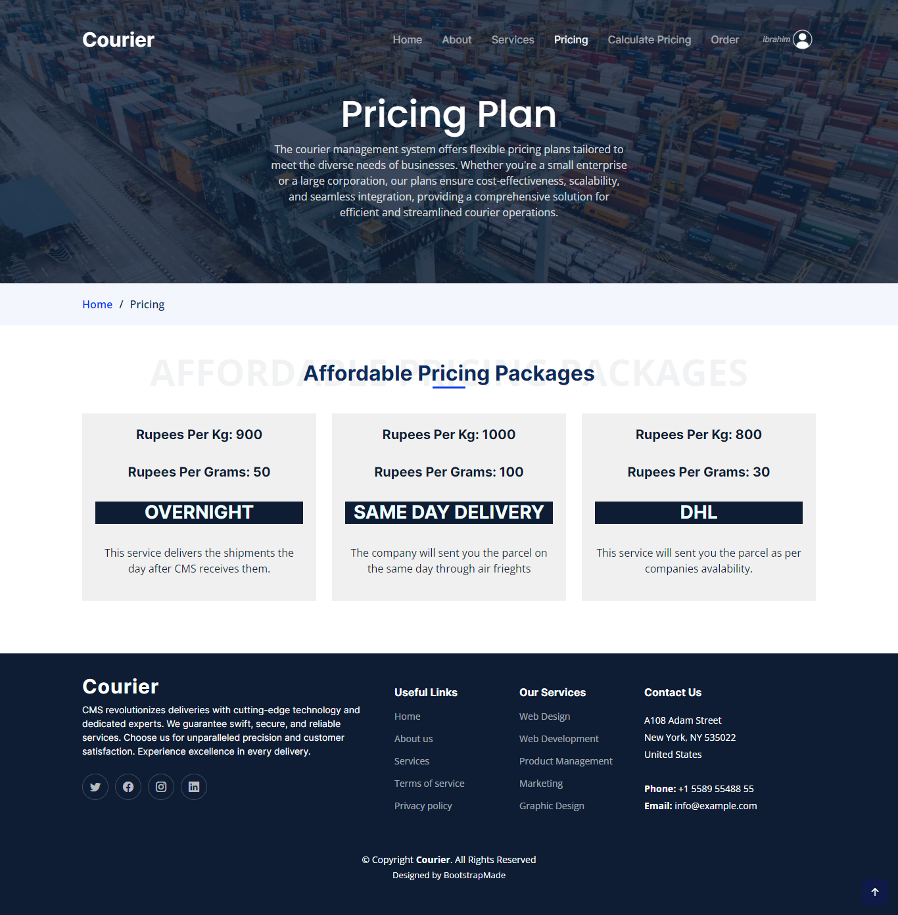

CODE:

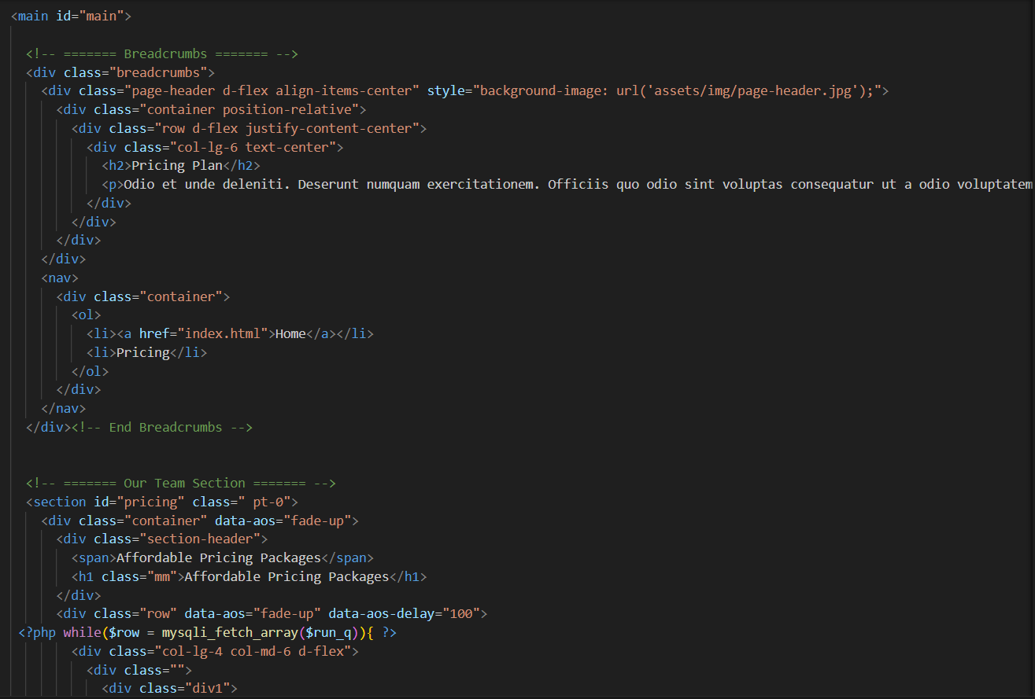

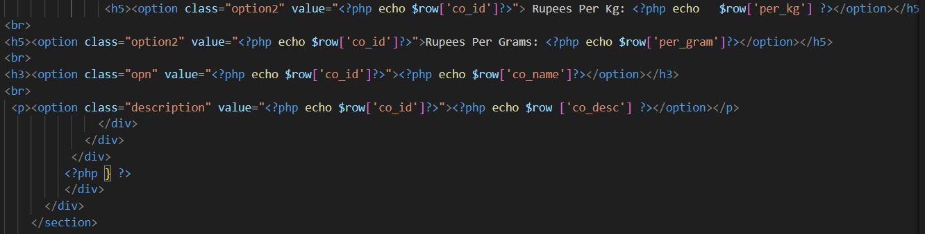

FOOTER:

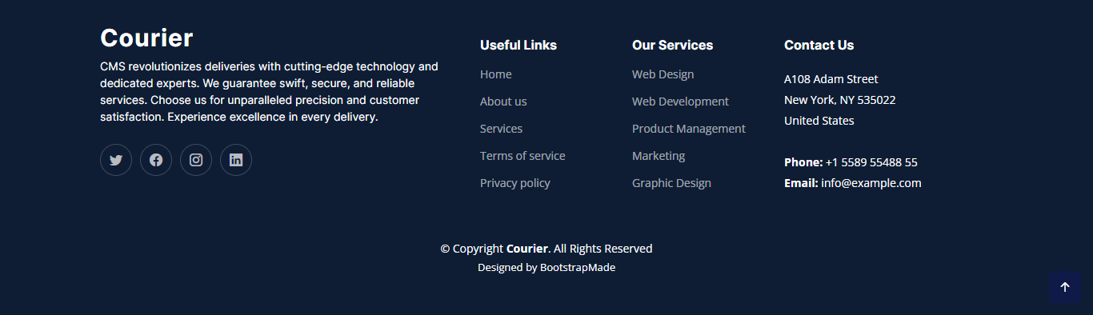

CODE:

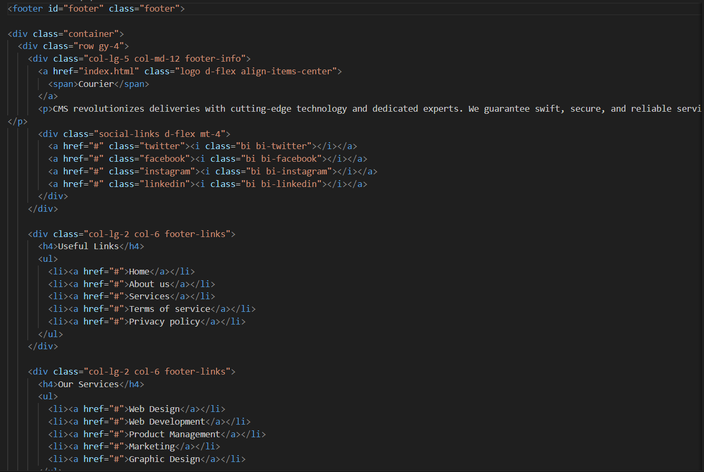

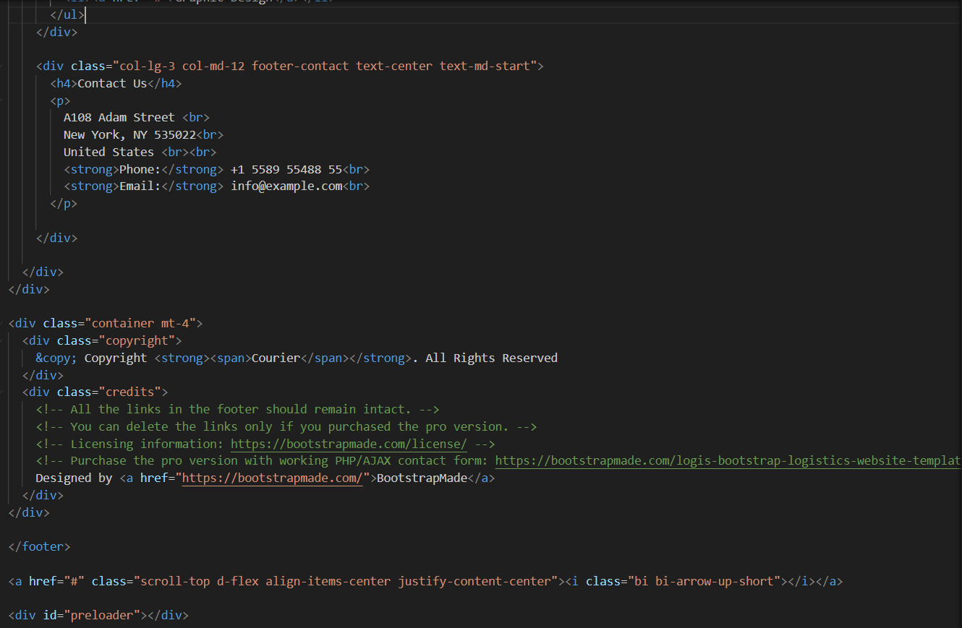

LOGIN:

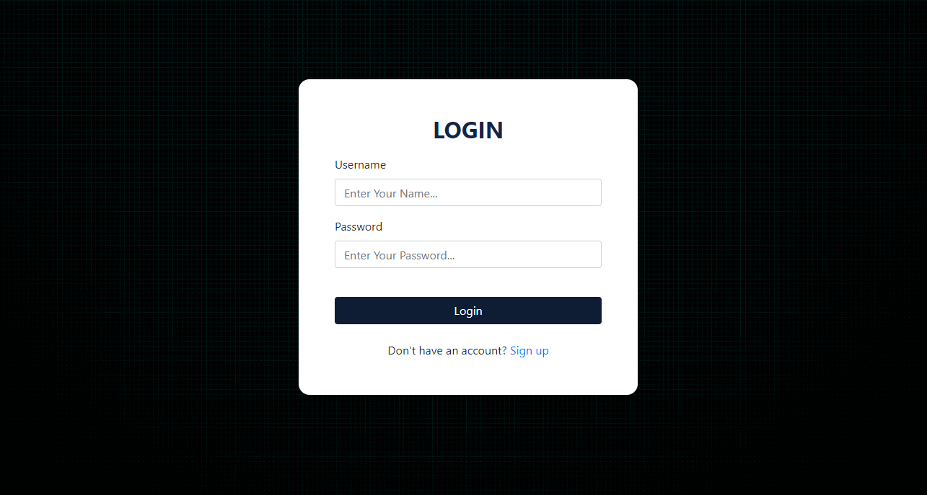

CODE:

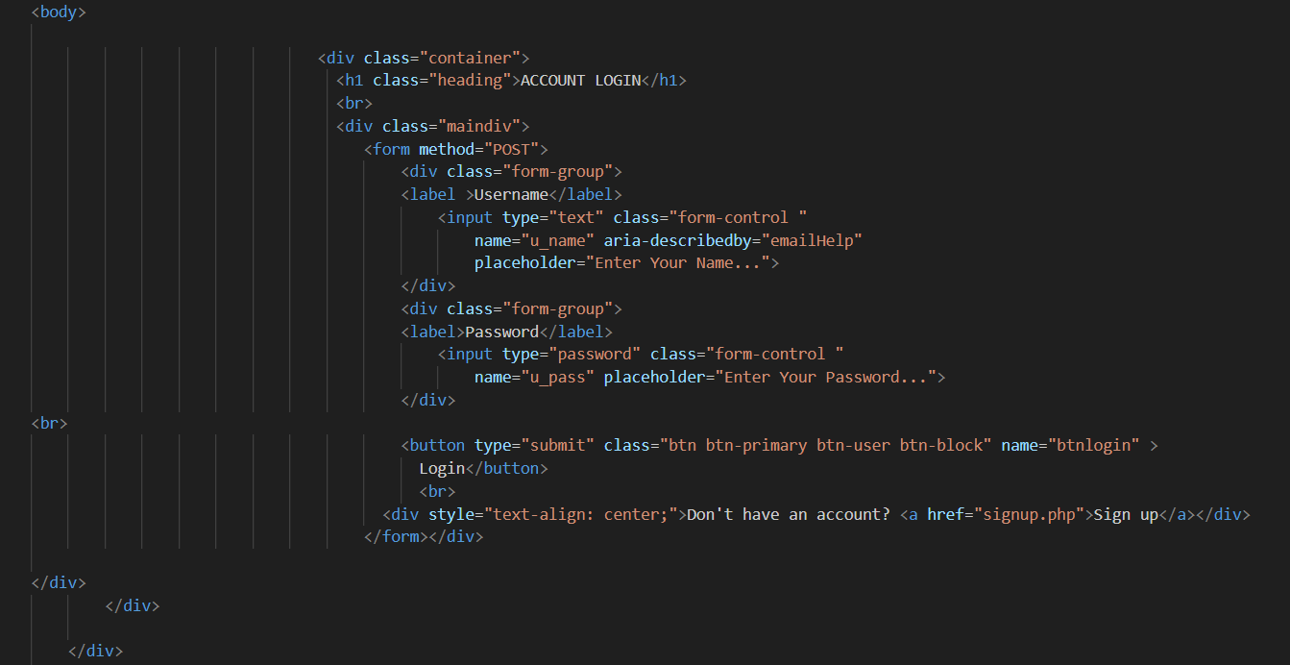

SIGNUP:

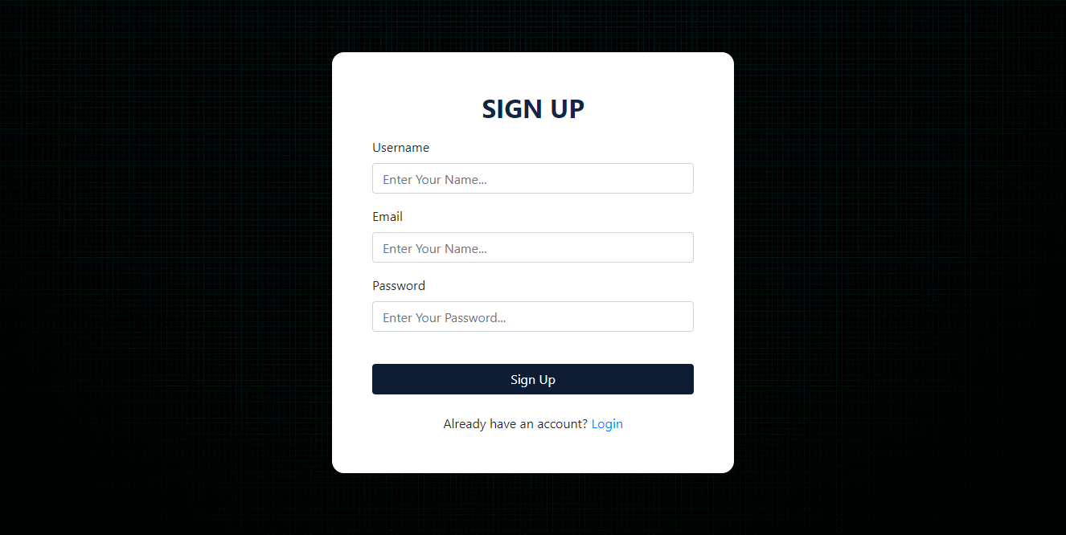

CODE:

